Head of Motorsport & Agricultural Engineering

Application Pack

TABLE OF CONTENTS

- Welcome letter from the Chief Executive & Principal Page 2

- About Myerscough College, Motorsport and Agricultural Engineering Page 3

- Job Description Page 8

- Employee Specification Page 15

- Useful Web Links Page 19

- How to Apply Page 19

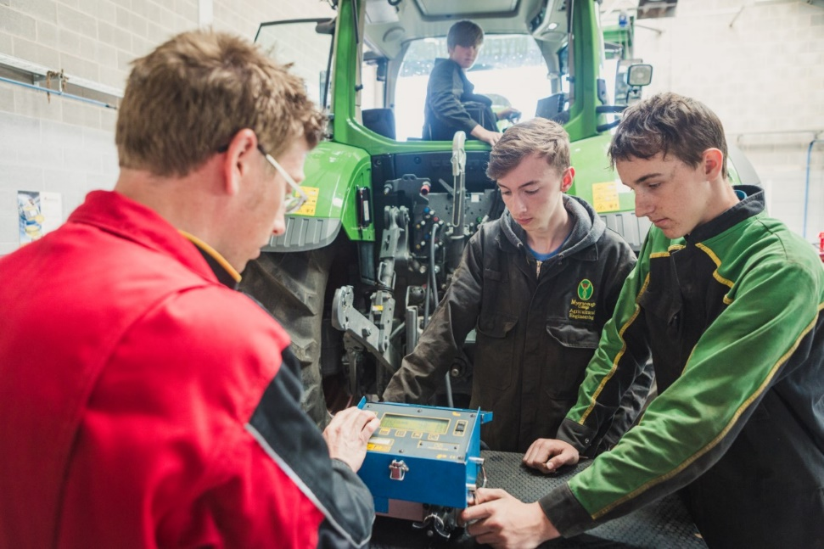

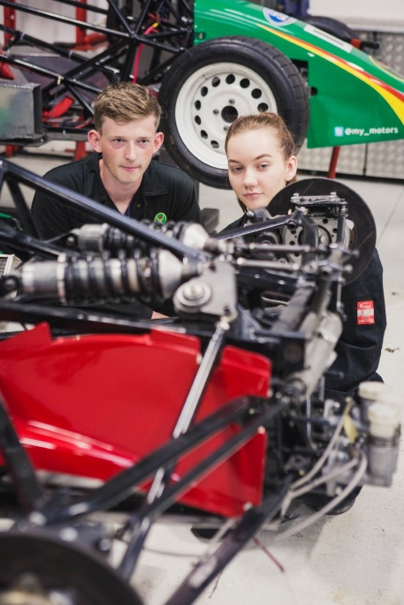

WELCOME LETTER FROM THE CHIEF EXECUTIVE & PRINCIPAL
Dear Candidate
Thank you for your interest in the role of Head of Motorsport and Agricultural Engineering at Myerscough College and University Centre (hereafter, called Myerscough College) in Lancashire and a very warm welcome to one of the leading specialist land based, science, engineering, and sports colleges in the country. This role will provide a strong, ambitious and passionate leader with the opportunity to make a significant contribution to the a Motorsport and Agricultural Engineering educational landscape of Lancashire and the wider North West of England.

Myerscough College has an annual turnover of c£34m and is rated by the Education Skills Funding Agency (ESFA) as “outstanding” for financial health. The person appointed will be a member of the College Management Team and will report to the Assistant Principal Further Education. The Head will be responsible for all aspects of decision making linked to the College’s Motorsport and Agricultural Engineering further education (14-16, 16-18 and adult education) and higher education provision and will work closely with colleagues in Apprenticeship and Skills for apprenticeships and short courses. They will additionally work with a wide range of teams to ensure a joined up approach to engineering education including teams working on the College farms, in Agriculture, Research, Agricultural projects and the wider farming community.

Working with our committed, knowledgeable, and enthusiastic Myerscough team in industry standard facilities alongside a wide range of regional and national partners, our mission is to inspire excellence. We pride ourselves in providing students with not only a first-class academic qualification but also the practical skills to meet the needs of industry and ensure their future employability. Delivering courses from entry to postgraduate level, alongside apprenticeships, Myerscough provides opportunities for academic progression, whilst strong industry links with over 1400 employers ensure that the courses are not only industry relevant but also provide the best opportunities to progress into employment.

The College is an inclusive, caring community, putting the needs of our students at the heart of all decision making and ensuring their safety and wellbeing is paramount. The College is judged by Ofsted as good for the quality of education and residential care of students and has a dedicated team providing student support and welfare, which ensures that each student is valued and able to gain confidence and achieve their full potential.

We believe that Myerscough is a special place to live, work and study and we are truly passionate about the future for Myerscough and the difference it can make to so many individuals. We are now seeking an inspirational and dynamic leader who is fully committed to building further on the current successes of the College ensuring an outstanding reputation for Motorsport and Agricultural Engineering education and training, research and knowledge transfer services to our students and wider stakeholders.

If you are interested in joining the Myerscough team and pursue your interest in this unique opportunity, then I look forward to receiving your application.
Alison Robinson
Chief Executive & Principal

ABOUT MYERSCOUGH COLLEGE AND MOTORSPORT & AGRICULTURAL ENGINEERING

Myerscough College is a specialist land based, science, engineering and sports college based near Preston in Lancashire with centres in Liverpool, Blackburn, Manchester, Penrith and Warrington. It delivers courses from entry level to postgraduate within these specialist areas, supporting not only the local but also the regional, national, and increasing international skills need. It was originally established as Lancashire County agricultural training centre in 1894, making it not only one of the largest but also one of the oldest specialist colleges in the country.
The College offers Motorsport and Agricultural Engineering courses at Further Education (FE 14-16, 16-18, adult education and apprenticeships) and Higher Education (HE) and is considered a leading national educational institution in these sectors. Motorsport and Agricultural Engineering are both taught solely from our dedicated workshops at our Bilsborrow site, near Preston, Lancashire. The College has a separate building for each subject with the Motorsports provision being delivered in our Motorsports Centres (bikes and cars) and Agricultural Engineering taught in our Engineering Centre. The buildings include specialist workshop space, IT, classroom and staff room space.

Agricultural Engineering students also access the College’s 300ha College Farm and associated machinery. The 2 College farms include a range of commercial livestock and crop enterprises – currently 200 dairy cows, beef from the dairy unit, a suckler herd, 1000 lowland sheep flock and combinable crops grown as forage – are all important both educationally and for research.

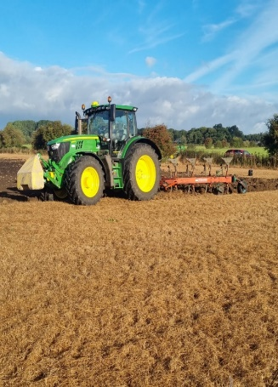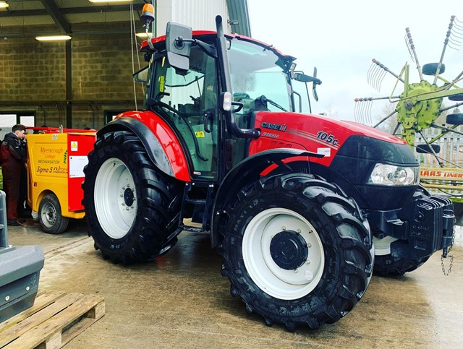

Myerscough College has seven motorsport workshops and a number of different competition
Myerscough College has seven motorsport workshops and a number of different competition cars for the continuing development and expansion of motorsport teaching. We believe that hands-on experience is an important aspect of learning and therefore encourages students to take part in a wide range of motorsport events throughout the UK. The department also now features a new motorcycle workshop for the learners on our motorcycle programme. We believe that hands-on experience is an important aspect of learning and therefore encourages students to take part in a wide range of motorsport events throughout the year.

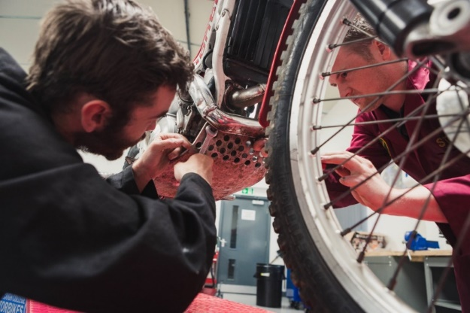
Our courses in Motorsport and Agriculture Engineering incorporate a mix of practical vocational lessons, classroom lectures, industry visits, and case studies. To enhance students’ wider employability skills students are engaged in arrange of course enhancement and enrichments events such as Car Club, tractor road rally events, residential and day trips and have guest speaker talks. Our Agricultural Engineering students have been involved in charity tractor runs in the UK and Ireland and running Dyno Days for local farmers to test the horse power of their machinery. Whilst our Motorsports and Motorbike students attend a variety of track days, rallys and events associated with their industry both in the North West and further afield. The highlight of Motorsports students time at Myerscough is supporting the Legends Fire North west Stages road rally that is hosted at the College with around 125 rally cars undertaking servicing, pit crew, logistics, marshalling and scrutineering activities at the College.

To further enhance students’ employability our students’ study a range of additional qualifications as part of the curriculum offer designed to meet the needs of industry. These include Tractor Driving, All Terrain Vehicle handling, Oxyacetylene welding, Manual Metal Arc welding and Metal Inert Gas welding as well as GCSE or Functional Skills qualifications in English and Mathematics.

The College prepares students to work to the highest standards in their industry. Learner behaviour in class is a real strength with staff promoting professionalism in all aspects of student learning. External customers and members of the public have often commented on the appearance and behaviour of our students at external events as exemplary. In both Motorsport and Agricultural Engineering, the whole ethos is that of team work and we have many students that have built on these skills and gone on to work in the highest echelons of their professions for example with Blue Chip Agricultural Engineering Companies, Formula One and World Rally Teams.

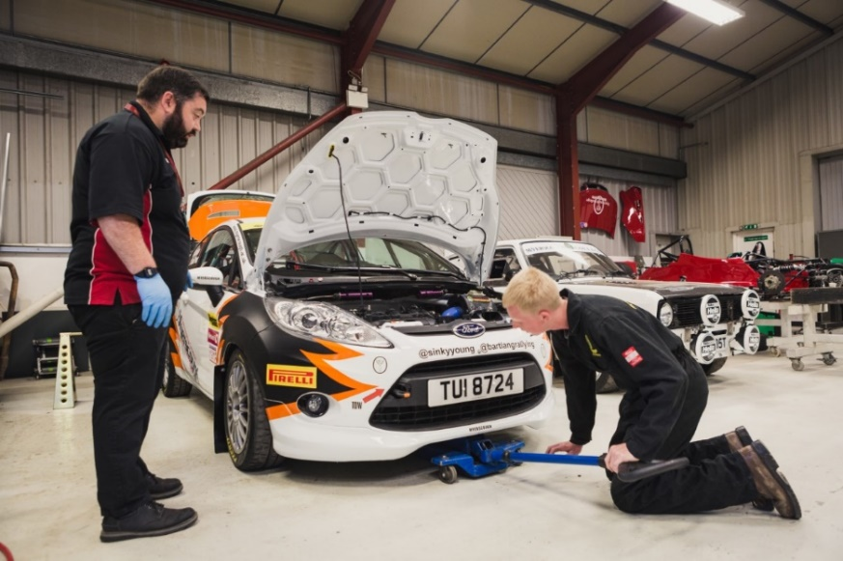
the UK. The department also now features a brand new motorcycle workshop for the learners on our new
programme

Investment in College Resources
In order to support the achievement of our students the College recognises an essential need to invest in its facilities and in new technology to support curriculum delivery and business development.
In 2017 the College opened a new Food and Farming Innovation and Technology Centre (FFIT) to support the adoption of precision farming techniques particularly within the livestock and grassland sectors. Whilst the Centre itself provides training, conference, and laboratory facilities the project also supported the investment in new facilities and technology for the farm itself. This included –
- 100GB data connection to all farm sites.
- Wi-fi coverage of all farm sites.
- New livestock building with associated silos, feed and slurry storage
- Milking parlour upgrade with Afi Milk technology.
- Precision fertiliser spreader.
This investment in technology has allowed significant improvements in farm performance to be achieved. It has also driven changes within curriculum delivery that has led to the use of the technology being embedded within teaching. This has been positively received by students and has helped drive increased student recruitment.
The investment in technology and resources made possible by the original FFIT project has also created significant knowledge transfer opportunities for agricultural engineers and to date several thousand farming businesses have visited the centre to gain an understanding of how the adoption of technology could assist their own business.

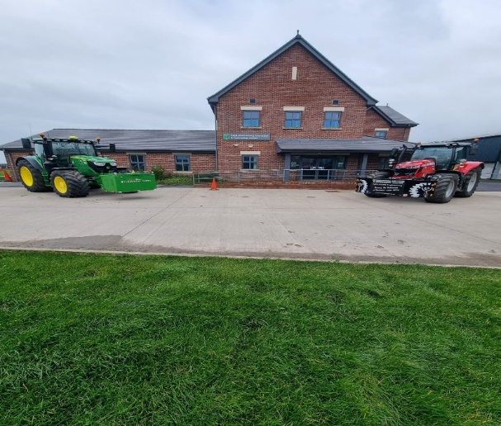

In 2019 the College secured further funding to invest in new calf rearing facilities, which again included the adoption of automated feeding technology. In the spring of 2020, the College opened a new calf rearing facility using Holm and Laue veranda and igloo system in conjunction with automated feeding stations with weighing capability. Again, this investment has brought about labour savings and enterprise performance improvements whilst at the same time creating further opportunities to deliver knowledge transfer activities for farm businesses.
Based on this continued investment in technology the College dairy unit was selected as an AHDB Strategic Dairy Farm in the autumn of 2020 and has since hosted a series of events for levy payers.

In addition, the College has led a £9m pilot of the Strategic Development Fund across the Lancashire Colleges on working towards the net zero carbon agenda. This has included Myerscough College’s ‘Ag Net-Zero Challenge’ which has involved working with local farmers and growers to address the question of “What about carbon?”. This challenge has attempted to demystify carbon management for individual businesses by providing solutions, making efficiencies, and improving productivity while reducing carbon footprint.
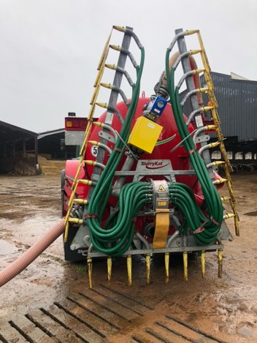
The Myerscough College Ag Net Zero Challenge has completed ten carbon audits across various farm types in Lancashire. These audits demonstrate where the carbon emissions are occurring and the necessary mitigation measures to reduce them including a range of agricultural engineering solutions. The College has also delivered Carbon Farm Roadshows and presented the results of the audits to groups of Lancashire farmers and to our College students. To support the project a range of innovative capital equipment has been purchased to enable teaching and learning at Myerscough College to be demonstrated by using the latest technology including the latest tractors, harvest lab, umbilical, direct drill, and self-propelled feeder wagon with cutter head technology.
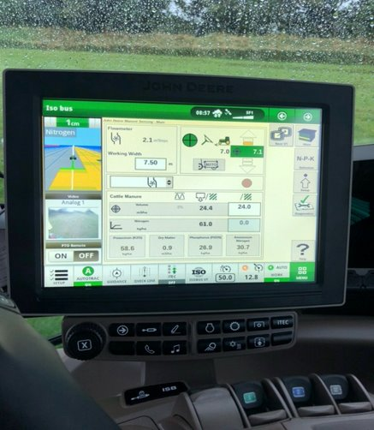

To continue this direction of travel the College has allocated funding and made a further grant application to support the installation of robotic milking into the existing dairy unit. Design work has been completed and tenders received in readiness for confirmation of the grant funding. The installation is scheduled to be complete by November 2022 and should again allow the farm to continue to demonstrate the adoption of precision farming technology and further enhance the farms capability to support modern training for students and allow other farm businesses to understand how the adoption of technology can assist their own business.
The College farm work in conjunction with researchers at both University Centre Myerscough and other universities to carry out research towards Masters and PhDs and to support funded research. The College is currently undertaking work around agricultural data technology with specific projects around milk parlour automation data and arable land treatment.
The College Motorsport team have had similar new investments. The College is recently purchased a brand-new Opel Corsa E rally car with the vehicle being completely electric and producing no emissions. It is the only example in private hands in the UK, having been built by Open Motorsport Germany and directly imported to Myerscough College. The car boasts a power output of 100KW (130 BHP) and has 260Nm of torque. The fully charged batteries have a range of 200 miles. 2019 European rally Champion, Chris Ingram, on his recent visit to the College during the NW Stages in March 2022 described it as an “awesome piece of machinery”. The Opel Corsa E rally car is the most recent addition to the College’s electric fleet, having been funded by the UK Government Skills Accelerator Initiative. It joins our BMW I3 hill climb car, Peugeot E Traveller service van and our Fiesta ST-line mild hybrid which is in the process of being made in a full rally car.

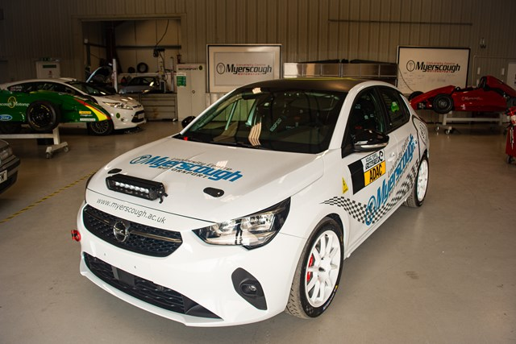

With the move towards a greener future, Myerscough College and University Centre Myerscough is proud to be leading the way in training the next generation of technicians and engineers.

JOB DESCRIPTION

JOB TITLE | AREA OF WORK
Head of Motorsport & Agricultural Engineering | Curriculum
SALARY | BENEFITS
£35,819 - £45,333 per annum  relating to qualifications and experience | Teachers’ Pension  40 days holiday plus Bank Holidays.  Plus up to 5 days at the discretion of the Principal to be taken between Christmas and New Year.
LINE MANAGER(S) | LINE MANAGER FOR
Assistant Principal Further Education | Staff allocated to the learning area
KEY TASKS AND RESPONSIBILITIES
- To be responsible for the planning, quality, organisation and development of the College’s portfolio of courses in the Motorsport and Agricultural Engineering learning area.

- To provide academic leadership and co-ordination for Motorsport and Agricultural Engineering at Myerscough and the College’s other campuses.

- To have direct responsibilities for staff management and recruitment of suitably qualified staff for Motorsport and Agricultural Engineering.

- Recruitment, attendance, retention, satisfaction and achievement of students in Motorsport and Agricultural Engineering.

- To have responsibilities for curriculum planning and costing for efficiency, timetabling and staff organisation and utilisation to agree contractual obligations.

- To have direct responsibility for the income and expenditure budgets for Agriculture & Countryside.

- The main focus of the Head of Area position is the academic leadership and management of Motorsport and Agricultural Engineering. This will cover Research, Higher Education, Further Education, the 14-16 curriculum and courses for industry and employer engagement that are commercially viable. The Head of Area will have direct responsibility for academic quality standards and achievement in the learning area.

- The role will include collaborative working with the following areas across the college and externally:
- Close links with the Myerscough Farm
- Agriculture and Countryside Team
- Agricultural Projects Team
- Apprenticeships and Skills Engineering Team
- Farmers Networks / Groups
- Building links with the wider motorsport and agricultural engineering community

DUTIES
Leadership and Management

- To provide academic leadership for Motorsport and Agricultural Engineering at Myerscough. This will include external liaison with professional bodies, universities, motorsport and agricultural engineering sector bodies and employers.

- To be responsible for the achievement of targets for course recruitment, attendance, retention, student satisfaction and achievement.

- Engage with external organisations to capitalise on good practice and promote a shared culture of continuous quality improvement throughout the college.

- Support Ofsted inspection, Office for Students/Quality Assurance Agency Review, Matrix accreditation, Landex Reviews, TEF submissions and other inspection / audit / accreditation activity and peer reviews.

- Work with senior and other managers and College staff to ensure that the College is an inspirational institution, which sets the highest standards through the ethos of continuous quality improvement maintaining agreed College values and the College Strategic Plan.

- Work collaboratively with other managers and all members of the senior management team in delivering college targets and priorities, which may include involvement in drawing up ambitious and innovative courses and bids in line with the College strategic plan and Local Skills Improvement Plans and other initiatives.

- Utilise industrial and other market intelligence software to match the curriculum offer under OFSTED “intent” planning to match the industrial and green skills strategy locally, regionally and nationally providing the labour force for the future.

- Maintain and enhance the College profile, reputation and performance through collaborative partnerships locally and where appropriate to do so, also regionally and nationally.

- Lead and support the marketing, social media, public relations and recruitment initiatives of the College to ensure courses within Motorsport and Agricultural Engineering are innovative, viable and efficient.

- To manage the pay and non-pay income and expenditure budgets for Motorsport and Agricultural Engineering.

- To lead the drive to improve quality standards in Motorsport and Agricultural Engineering and to ensure the very high-quality expectations are maintained in the subject discipline at Myerscough and the College’s other centres.

- To conduct effective line management of the staff team, including supporting and leading the recruitment of high calibre staff. This will involve target setting and staff review, the conduct of lesson observation and the provision of the relevant coaching and support for staff. The Head of Area will be responsible for the efficient and effective utilisation of staff, and promoting a high standard of work and professional conduct.

- To plan and allocate staff and physical resources at Myerscough in a manner which makes optimal use of resources to deliver high quality education and training. This will involve responsibility for curriculum planning, the development of timetables and close working relationships with the College’s farm operations team.

- To ensure physical resources are serviced and maintained to a high standard. To be responsible for the health and safety of staff and students both on campus and whilst on off campus activities.
DUTIES
Leadership and Management (continued)

- To support the delivery of courses in the relevant subject discipline at the College’s other centres where applicable. This will include liaison with the relevant Heads of Centres, the organisation of relevant internal verification, as well as standardisation of quality processes, ensuring that external quality assurance processes are properly and professionally met to the highest standard.

- Ensuring a positive and high-quality student experience, including considered design of FE and HE programmes that include employability and personal development opportunities.

- To work with the Assistant Principals of Curriculum for FE and HE and the Director of Quality to ensure that the portfolio of courses is delivered effectively and to the high-quality standards the College requires.

- To develop full cost course activity and employer engagement for Motorsport and Agricultural Engineering including the organisation and leadership of the subject technical advisory board to ensure effective liaison with employers.

- To participate in inspections and audits when these are initiated either internally within the College or by external bodies.

- Manage all teachers to meet annual Continuing Professional Development (CPD) requirements.

Strategy and Policy

- To work closely with the Director of Quality & Performance to ensure that observation of teaching and learning reporting systems and targets are consistent across the College and are owned and understood by teaching teams.

- Oversee the development and implementation of relevant policies, procedures and quality initiatives linked to teaching and learning.

- Support, develop and implement the Motorsport and Agricultural Engineering SAR process in a timely way.

- Develop and support the college’s data and MIS reporting capabilities to provision of accurate, relevant and timely management information.

Teaching, Learning and Assessment

- Manage the quality assurance of teaching, learning and assessment to ensure continuous improvement and a positive and dynamic learning culture permeates the provision.

- Through proactive data monitoring and analysis, identify and implement improvements in teaching and learning and outcomes in liaison with the Director of Quality & Performance.

- To ensure that development priorities are identified and actioned, providing CPD to support teaching and learning priorities.

DUTIES
Teaching, Learning and Assessment (continued)

- Create and sustain a culture of curriculum excellence, innovation and delivery that provides for exceptional teaching and learning across the College.

- To support the recruitment of new teachers by involvement in both the pre-interview tasks and the interview process itself, as required.

- As part of the role an agreed amount of teaching will be required in order that the Head of Area retains and implements current teaching principles.

- Actively bid for and manage externally funded projects that drive forward teaching, learning, assessment and employer engagement.

Stakeholder Voice

- Work proactively with the Quality leads to plan and develop stakeholder feedback systems including student surveys and focus group, staff surveys and the associated responses and action plans to maintain a listening and responsive culture.

Quality Improvement

- Work with the Director of Quality and Performance to deploy and support the Teaching and Learning coaches to ensure appropriate support, management and intervention across all Quality Assurance processes and procedures with academic staff.

- Work with the Director of Quality and Performance to drive Performance Management through monitoring meetings and agendas and oversee cause for concern and improvement notice requirements.

- Effectively use solution focussed approaches and activities to drive continual quality improvements across curriculum.

- Actively participate in external reviews and other related standards to ensure that accurate and comprehensive evidence of teaching and learning performance is presented.

- To help raise the profile of the learner’s voice and engagement ensuring that it is a natural part of the quality improvement process and informs curriculum developments to improve teaching, learning and assessment strategies, policies and practices.

- To take a lead with the enhancement and use of the college monitoring systems and management information system ensuring all staff teams are supported and proactive in its use.

Digital Skills in the Organisation

- Support the management and development of a whole-organisation approach to interactive e-learning that encourages staff and learners to become independent users of ILT.

DUTIES
Digital Skills in the Organisation (continued)

- Work with the Digital Learning and Skills manager to actively develop and promote systems and processes around ‘digital literacy’ ensuring it is a recognised agenda for the College.

- Support strategic decisions about the digital environment ensuring they are made with full consideration and consultation with students and student-facing staff.

- Work with the Digital Learning and Skills manager to ensure ILT developments exceed national expected standards and contribute to enhancing the student experience and College reputation.

- Support a whole-organisation approach to digital learning that encourages staff and learners to become independent users of technology enhanced learning.

- Work collaboratively with the Advanced Teaching Practitioners to identify and embed industry best practice in technology enhanced learning into teaching, learning and assessment.

- Work proactively with the Continuous Professional Development and Digital Learning and Skills Managers to provide inspirational and appropriate training for teaching staff that encourages them to embrace technology enhanced learning in providing highly effective learning opportunities.

- Help develop a culture of support and appropriate learning environments that encourage staff and students to experiment with information learning technology and establish new practices.

- Work with the Teacher Learning Coaches and Digital Learning and Skills team to use research-informed decisions on technology enhanced learning to ensure cost-effective deployment of new equipment and/or techniques.

Continuous Professional Development (CPD)

- Work in collaboration with HR & CPD to ensure there are regular opportunities for staff engagement and support linked to staff individual need, performance review and feedback.

- Work with the Teacher Learning Coaches and other managers to identify good practice internally and externally and ensure this is shared throughout the organisation through multiple communication channels.

- Actively promote and embed the Professional Standards for Teaching and Training – England within the College, including the professional values, attitudes, knowledge, understanding and skills.

DUTIES
Freedom, Respect, Equality, Diversity, Inclusion & Engagement

- Support equality, diversity and inclusion strategies across the College to promote and advance equality, diversity and inclusion, supporting teams to understand and remove any barriers and address any gaps in teaching, learning and assessment strategies, participation and achievement.

GENERAL DUTIES
- You role model and promote the College values:

- Learning - Our delivery will be high quality and innovative with students at the heart of decision making.
- People - We will enable staff and students to fulfil their potential whilst promoting resilience, leadership, accountability and teamwork.
- Sustainability - We will provide a happy, healthy, safe, supportive and sustainable environment in which to live, work and study.
- FREDIE - We will advance FREDIE: Fairness, respect, equality, diversity, inclusion, engagement in all we do.

To promote Equality, Diversity and Inclusion at every opportunity.

Lead and advance the FREDIE principles.

Promote College sustainability policies and strategies by personal commitment and lead by example.
Active involvement in carbon reduction, embedding of carbon reduction practices (lights off, heating down etc. )

To be vigilant in relation to the College’s approach to Reduce, Reuse and Recycle ethos.

Take an active role in all team activities to ensure full compliance with agreed safety, quality and environmental standards and expectations.

Participate in staff review and development in line with College needs. Agree objectives with the Line Manager and ensure they are achieved.

Maximise effective use of time and personal ability.

Be responsible for promoting and safeguarding the welfare of children, young people and vulnerable adults at all times in line with the College’s own Safeguarding Policy and practices.

Work flexibly within own range of competence, undertaking the appropriate training and development to extend skills and abilities to meet the needs of the College.

Be committed to working towards the implementation of equality of opportunity in both service delivery and employment. The College’s mission and strategic objectives directly support this aim. All employees are required to support this aim and its implementation pro-actively.

DUTIES
Must be thoroughly aware of College Health and Safety policies and procedures and attend any mandatory health and safety training appropriate to their role and ensure that employees within their responsibility are also made aware of these policies and procedures and any mandatory training relevant to their role. They must also seek to ensure appropriate implementation of such policies and procedures across all areas of their responsibility.

Ensure all accidents and near misses are recorded and reported following College procedures.

Adhere to the Data Protection Act 1998 and the General Data Protection Regulations 25 May 2018 and must be thoroughly aware of the College Data Protection Policy and Procedure and ensure that employees within his/her responsibility are also. He/she must also seek to ensure appropriate implementation of such policies.

Any other duties that may reasonably be required by Line Management and the Principal.

Location of work
You may be required to work at or from any building, location or premises of Myerscough College, and any other establishment where Myerscough College conducts its business.

Variation to this Job Description
This is a description of the job as it is at present, and is current at the date of issue. The job description will be renewed and updated as necessary to ensure that appropriate revisions are incorporated, and that it relates to the job to be performed. This process is conducted jointly with your Line Manager. You are expected to participate fully in the review and, following discussion, to update your job description as is considered necessary or desirable. It is our aim to reach agreement on reasonable changes. However, if such agreement is not forthcoming, Management reserves the right to insist on changes after consultation with you.

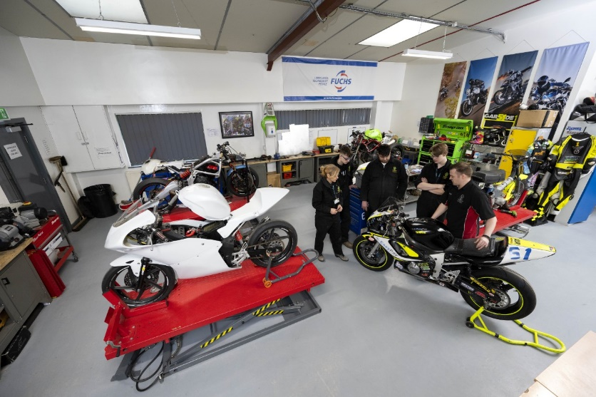

EMPLOYEE SPECIFICATION

(A) Assessed via Application form ( I ) Assessed via Interview
(P) Assessed via Presentation in interview (T) Assessed via Test

ESSENTIAL CRITERIA: | DESIRABLE CRITERIA:
Personal Attributes
Presentable and professional appearance (I)
Ability to work as part of a team (A/I)
Ability to work to quality standards (A/I)
Good command of the English language (A/I)
Appropriate level of physical and mental fitness (PI)
Highly motivated with a commitment to succeed (A/I)
Attainments
Degree in related subject (A)  Experience in Motorsport, Agricultural Engineering or related industries (A/I/P)  Experience in the Further/Higher education sector. (A/I/T/P)  Teaching Qualification e.g. PGCE / Cert Ed (A/I)  GCSE, or equivalent, English & Maths grade C or above (A/I) | Postgraduate qualification in a related subject (A)  A1 Assessors award or equivalent (A)  Leadership & Management Qualification (A)
General Intelligence
Ability to lead and manage a team of academic staff (A/I/T/P)
Special Aptitudes
Leadership/ communication skills and the ability to motivate a team (A/I/T/P)
Significant amount of teaching experience and knowledge of developments in teaching and learning (A/I/T/P)
Interests
Interest in subject discipline (A/I)  Interest in the work and achievement of students (A/I)  Interest in relevant aspects of their programme area and related quality issues (A/I)  Empathy with education (A/I) | Involved in subject industry (A/I)
Disposition
Excellent interpersonal skills (I)
Good communication skills (I)
Approachable (I)
Person centred approach (I)
Capable of developing the performance of team members (I)
Ability to recognise the importance of recruitment, retention and achievement (A/I)
General
A good understanding of “safeguarding” and its importance within the College * (A/I)
A good understanding of health and safety requirements of a working environment (A/I)
A good understanding of Equality, Diversity and Inclusion issues within an educational context (A/I)
Circumstances
Willing to apply for Disclosure & Barring Service clearance at Enhanced level (important – further information below).
(A/I)
Ability and willingness to work flexibly (I)
Possess a current driving licence or willing to travel as required by other means (A/I)

*
Interviews will explore issues relating to safeguarding and promoting the welfare of children, including motivation to work with and ability to form and maintain appropriate relationships and personal boundaries with children and young people together with emotional resilience in working with challenging behaviours and attitudes to use of authority and maintaining discipline..

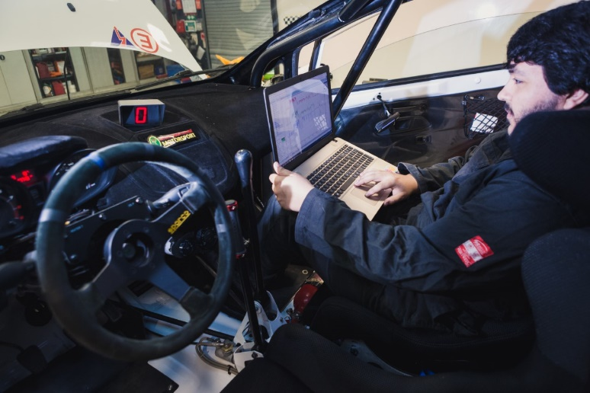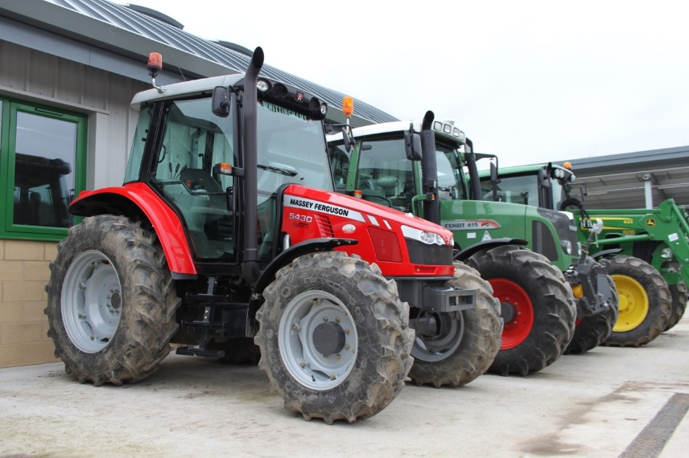

EMPLOYEE SPECIFICATON
TERMS AND CONDITIONS

JOB TITLE | AREA OF WORK
Head of Motorsport and Agricultural Engineering | Curriculum
SALARY | HOURS OF WORK
£35,819 - £45,333 per annum  relating to qualifications and experience | 37 hours per week
ANNUAL LEAVE ENTITLEMENT | PENSION
40 days holiday plus Bank Holidays.  Plus up to 5 days at the discretion of the Principal to be taken between Christmas and New Year. | Teachers’ Pension Scheme  Up to £29,187.99 pa 7.4% Employee  £29,188 - £39,290.99 pa 8.6% Employee  £39,291 - £46,586.99 pa 9.6% Employee  £46,587 - £61,742.99 pa 10.2% Employee  £61,743 - £84,193.99 pa 11.3% Employee  £84,194 and above pa 11.7% Employee  23.68% Employer  You will automatically become a member of the TPS
PROBATIONARY PERIOD | DRESS CODE
A probationary period of nine months applies to new entrants to the College | All post holders are expected to be of a professional and presentable appearance

REFERENCES / MEDICAL CLEARANCE / DISCLOSURE
The appointment is subject to the receipt of satisfactory references, medical clearance and Disclosure & Barring Service check/ISA (if applicable).
Occupational Sick pay is not paid during the first four months of service and thereafter is subject to the College’s Sick Pay Scheme

Should your application be successful you will be sent further details via email from eSafeguarding. They are the Registered Umbrella Body we have chosen to complete the Disclosure and Barring Service (DBS) process on your behalf.

Please note that all new employees of the College will be required to pay for their DBS check via eSafeguarding at the time of application (at present £40.00 for an enhanced level check).

DBS UPDATE SERVICE

The Disclosure and Barring Service (DBS) update service lets applicants keep their DBS certificates up to date online and allows employers to check a certificate online.

BENEFITS TO YOU | HOW TO REGISTER
- Saves you time and money  - One DBS certificate may be all you will ever need  - Take your DBS certificate from role to role within the same workforce  - You are in control of your DBS certificate  - Get ahead of the rest and apply for jobs DBS pre checked | You can register online as soon as you have your application reference number. You can ask for the number when you apply for your DBS check.  Or you can wait and register with your certificate number when you receive your DBS certificate. If so, you must do so within 30 days of the certificate being issued.  To check the progress of your DBS certificate use the DBS tracking service.  Registration lasts for 1 year and costs £13 per year (payable by debit or credit card only).  You’ll get an ID number with your registration that you need to log on to the service. Make sure you write it down.

WHAT YOU GET
When you join, you’ll get an online account that lets you:
- Take your certificate from one job to the next
- Give employers permission to check your certificate online, and see who has checked it
- Add or remove a certificate

USEFUL WEB LINKS

- College Website www.myerscough.ac.uk
- LANDEX www.landex.ac.uk
- Skills Accelerator Project in Agriculture Ag Net-Zero Challenge – The Myerscough College Ag Net Zero Challenge

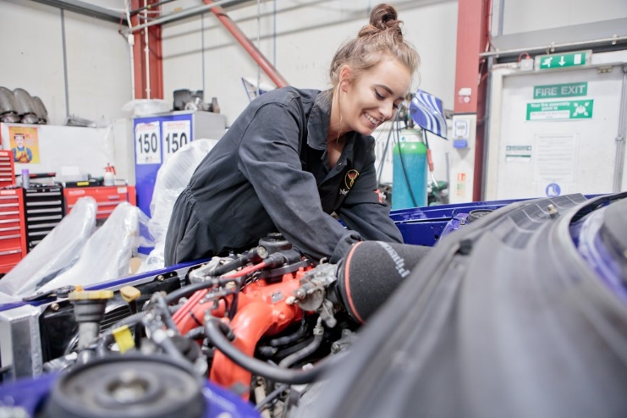

HOW TO APPLY

Please complete a full Myerscough College application form available from Myerscough College website under Vacancies. College website as detailed above.

Recruitment Timetable:

Closing Date for Applications | Wednesday 6th July 2022 at 12 noon
Assessment Centre | Thursday 14th July 2022

