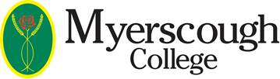

Dear Applicant

Re: 14-16 Maths and English/Functional Skills and/or Science Programme 2022

Thank you for applying to Myerscough College.

We have registered your application for the above course and are holding a space for you. You will be advised on the courses we can offer you after the assessments.

We plan to invite Learners onto Campus in June to take these assessments. This will assess what level Learners are working at to place them in the correct group for September. It is Mandatory that Learners attend for assessments and if anyone fails to do so they will risk having their conditional offer withdrawn. We will confirm the dates for the assessments in Term 3. Please do not contact us about this, we will keep you updated as soon as plans have been confirmed.

The interviews/assessments are for the Functional Skills, GCSE English and Maths and GCSE Chemistry and Biology if you applied for it. For guidance and the type of work you can look at in order to prepare please see the General Education Introduction letter here Letter from our General Education Team.

Please note GCSE Chemistry and Biology can only be offered to students who are studying the GCSE English and Maths course, not the Functional Skills route.

If you have any queries or concerns regards any of the above please contact the 14-16 co-ordinator Lydia Perry lperry@myerscough.ac.uk

Yours sincerely

The Recruitment and Admissions Team

