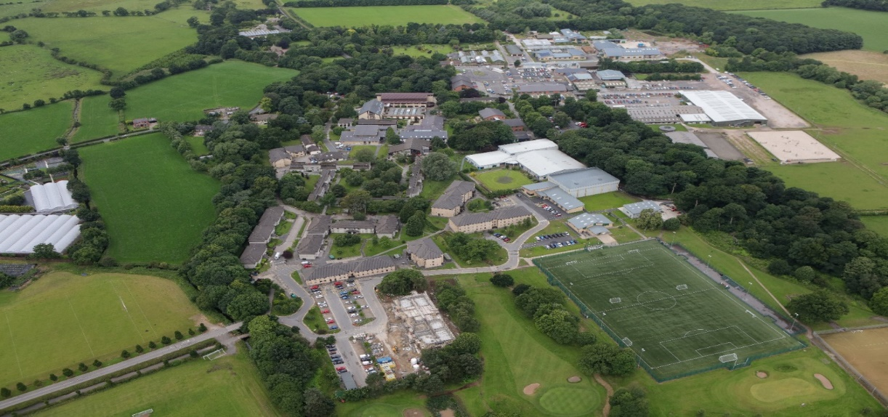
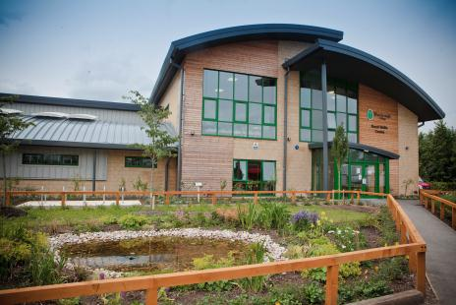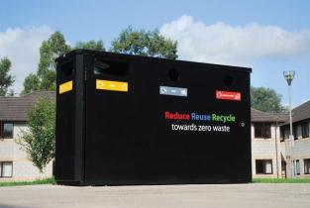
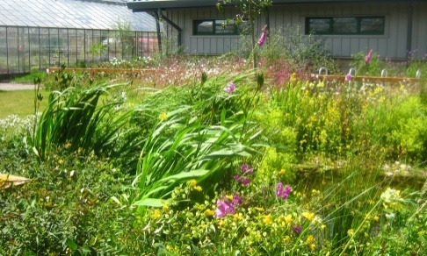

Streamlined Energy and Carbon Reporting 20 – 21

MARCH 2022

- Introduction
Myerscough College is a specialist land-based, science, engineering and sports college operating from a large rural site situated north of Preston, Lancashire. The College also operates from several other centres across the North West. The estate occupied by the College is incredibly diverse in nature and includes: general and specialist teaching resources to support a wide range of pre-16, Further Education, Higher Education and Apprenticeship programmes; residential accommodation for learners living on campus; equine facilities which support both curriculum and commercial activities; golf course; and, agricultural and farming facilities, again to support both curriculum and commercial activities.

- Energy Use and Carbon Emissions Data for 20–21 Year

Energy Consumption used to calculate emissions (kWh) | Aug 19 – July 20 | Current Reporting Year  Aug 20 – July 21
Electricity (kWh) | 2,911,509 | 2,810,974
Heating Fuels (kWh) | 907,228 | 490,741
Gas (kWh) | 7,878,100 | 9,111,555
Transport Fuels (kWh) | 577,441 | 385,850
TOTAL (kWh) | 12,274,278 | 12,799,120

 | Aug 19 – July 20 | Current Reporting Year  Aug 20 – July 21
Scope 1 Emissions in metric tonnes tCO2e
Gas tCO2e | 1449 | 1672
Heating Fuels tCO2e | 35 | 38
Owned transport tCO2e | 276 | 87
Total Scope 1 tCO2e | 1759 | 1797
Scope 2 Emissions in metric tonnes tCO2e
Purchased Electricity tCO2e | 679 | 655
Scope 3 Emissions in metric tonnes tCO2e
Business travel in Employee-Owned Vehicles, transmission, and waste tCO2e | 72 | 86
Total Gross Emissions tCO2e | 2509 | 2538
Intensity ratio (No. Staff) | 888 | 883
Tonnes CO2e per Member of Staff | 2.83 | 2.87

- Reporting Methodology

Reporting Period: 1st August 2020 – 30th July 2021

This report has been completed on a voluntary basis as the College is not required to report its energy and carbon emissions within its Annual Report. This is the second year of voluntary SECR carbon reporting and the data is assisting the College to determine the types of actions necessary to further reduce its carbon emissions.

The College has followed the 2019 HM Government Environmental Reporting Guidelines and the 2020 UK Government’s Conversion Factors for Company Reporting to calculate the data.

The College operates from a number of local authority-controlled premises in Blackburn, Liverpool and Warrington. The College also utilises premises which form part of Old Trafford Cricket Club in Manchester. All energy consumption data for these premises has not been available and estimated data has been included for the Liverpool and Warrington centres. The area of these premises is small in comparison to the rest of the college estate. The College will continue to work with the relevant authorities to obtain all the necessary information to improve the accuracy of the information reported.

The 2020 -2021 year was impacted by pandemic restrictions at various times and by the requirement to keep building well ventilated when in use. As a result, it has been concluded that the consumption data may not fully reflect a typical year.

- Intensity Measurement

The selected intensity measurement ratio is total gross emissions in metric tonnes CO2e per staff member, the recommended ratio for the sector.

- Measures Taken to Improve Energy Efficiency

During the reporting period the College has implemented a series of measures to reduce the carbon footprint from its activities.

- Installation of air source heat pump technology in premises at Croxteth Park Liverpool.
- Additional solar array capacity at Croxteth Park Liverpool.
- Replacement of five gas boilers with energy efficient models.
- Staff encouraged to continue the use of Microsoft teams and other software for virtual meetings to reduce travel by staff and suppliers.
- Staff encouraged to adopt a hybrid working model.
- Continued adoption of reduce, reuse and recycle principles in order to minimise waste.
- Further lighting efficiency improvements were completed as part of an on-going drive to improve efficiency.

Previously the College has implemented a wide range of carbon reduction measures. These have included power optimisation, installation of solar arrays on a range of buildings, installation of a combined heat and power unit and a number of biomass heating systems. Lighting has been updated in all buildings, older inefficient electrical appliances have been replaced, water consumption control measures introduced and paper consumption reduced through the adoption of technology solutions. A College wide reduce, reuse and recycle continues to operate and there has been good engagement from staff and students. Sustainability in all its forms is a strategic objective for the College and plans are now being developed to ensure that actions allow the achievement of government targets.

