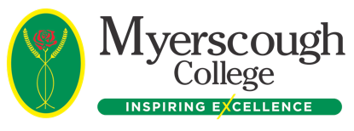
Myerscough College Short Course Employers Booking & Confirmation Form- SHORT ONLINE BUSINESS COURSE BOOKINGS ONLY

Company Name & Address: | Invoice Address:
Post Code: | Post Code:
Contact Name: | Contact Name:
Tel Number: | Tel. Number:
Email Address: | Email Address:
Purchase Order Number:

Please use these codes to identify which courses you wish to book for which employee
Asbestos Awareness – AA  Display Screen Equipment – DS  E-Safety – ES  Fire Warden – FW  Health and Safety at Work – HS  Manual Handling- MH | Coronavirus (Educational Settings) – CV  Environmental Awareness – EA  External Conflict Management – EM  Food Hygiene – FH  Internal Conflict Management – IM  Safeguarding and Prevent - SP | COSHH – CO  Equality and Diversity – ED  Fire Awareness – FA  GDPR Awareness – GA  Legionella Awareness – LA  Slips, Trips and Falls in Education - ST

Terms and Conditions

As all courses are on demand then no cancellations or refunds will be accepted
The College reserves the right to cancel or postpone any course however in the unlikely event that this happens we will endeavour to inform you of the situation and provide appropriate advice.
Any learning difficulties or medical needs that may impact on the candidates ability to complete the course must be disclosed.

We agree to the above terms and conditions

Signed: Date

Name:

Position in Company:

On Behalf of (Company Name):
Please turn over to fill in information about the individual candidates PTO

Delegate Information:
Title | First Name | Surname | Date of Birth | Home Address | Home Postcode | Home Phone Number | Mobile Number | Email Address | Codes for courses booked | Medical / Learning Need

Please see https://www.myerscough.ac.uk/privacy-policy/ This policy outlines what categories of information we retain and how we use it as per GDPR Regulations

Please return this form to:
shortcourses@myerscough.ac.uk

Together with the names and dates of birth of the candidates attending and your official order form if required.

Telephone number: Email:
01995 642386 shortcourses@myerscough.ac.uk

