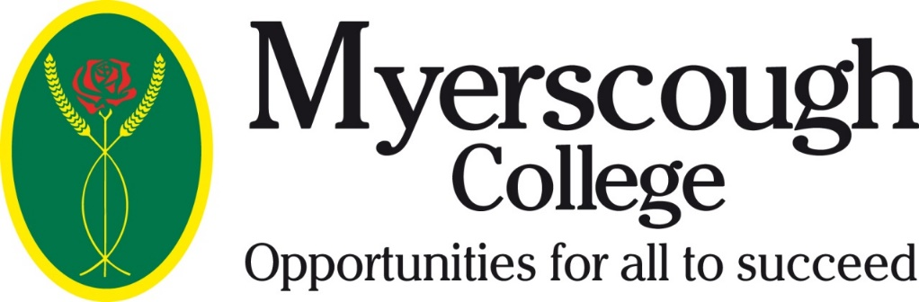

Confirmation of Home Education

Applicant Name: ___________________________DOB: ____________

Myerscough Course Applied for: ________________________________

I confirm that the applicant identified above is following a programme of Home
Education.

Parent/Guardian Signature: _______________________________

Date: ____________

Please return to Paul Park, Myerscough College, Myerscough Hall, Bilsborrow,
Preston, PR3 0RY or ppark@myerscough.ac.uk

Please ensure you have read and understood the information on the reverse of this document.

Parent/Guardian Information – Please retain for future reference

Myerscough College is a post-16 institution. Post-16 is defined as the student turning 16 years of age before 31st August in the year that they start their course.

In taking pre-16 students onto our courses the college must be confident that these students are
mature enough to thrive in a post-16 environment where they will have much higher levels of
individual responsibility than within a pre-16 institution.

In some cases, students may be rejected at pre-16 where it is felt the College is not an appropriate setting for a younger student, however this will not affect any future post 16 applications.

Myerscough College is not a specialist pre-16 Emotional Behavioural Difficulty provider, Pupil
Referral unit or LLDD Provider and reserves the right to refuse an applicant if it is decided that their needs as a pre-16 student cannot be met within the college environment.

Myerscough College is unable to access funding to provide inclusive learning support for Electively Home Educated students and may refuse to offer a place on this basis. We have limited access to the range of support services available to pre-16 providers so again may refuse an offer if it is felt the student requires access to these additional services to succeed.

The College is also unable to lead the application or review of Education Health Care plans for Electively Home Educated students although it may strongly be recommended that a parent or guardian pursues this option through their local authority.

Myerscough College cannot access any funding for students who are registered with a pre-16 provider. In this case the provider can agree to pay course fees to the College. The provider would also have to cover any support fees identified by the college as necessary.

Myerscough can access funding for pre-16 Electively Home Educated students. Registration onto a
full time course through Myerscough College does not affect a student’s legal Home Educated
status. If no offer is made or the student is withdrawn from the programme during the academic
year then the legal responsibility reverts to the parents or guardians for the provision of appropriate
education.

The College has no legal obligation to provide education for school age students who are
not accessing a college programme nor any means to provide this education.

In the same way a student registered with a pre-16 school or through the local authority does not
have a changed education status through registration on a Myerscough course. If an offer is not
made or the student is withdrawn during the academic year they again become the responsibility of
their home institution.

Students must not be withdrawn from a local authority school with the sole intention of accessing a
College course through the Elective Home Educated funding. There must be a commitment by
parents/guardians to provide Home Education. It may be that Myerscough College supplements this
education through its courses however the student should also be receiving education at home and
there should be the means to take on full time education should the student fail to receive an offer
or have the place withdrawn during the academic year.

