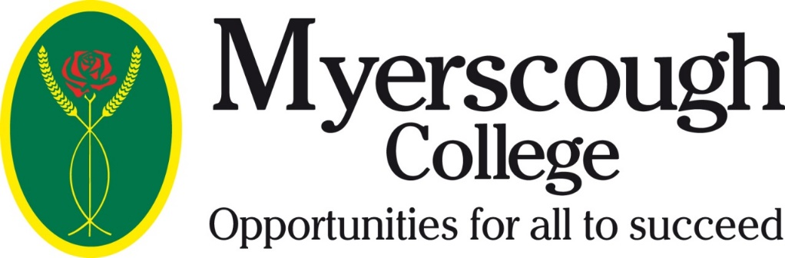

Confirmation of Home Education

Applicant Name:____________________________

Applicant DOB:_________________

Myerscough Course Applied for: ________________________________

I confirm that the applicant identified above is following a programme of Home Education.

Parent/Guardian Signature ________________________________

Date ____________

Please print, sign and return, prior to start date, to Laura Wallace, Myerscough College, Bilsborrow, Preston, PR3 0RY

