Myerscough International Arena

[](http://www.bing.com/images/search?view=detailV2&ccid=uXxBjutb&id=63A2680B1D2586B935A733A2BFD5C4A2F914F8BC&thid=OIP.uXxBjutb8VABBvuyhKZmCgEcEs&q=horses+cartoon&simid=607986234772227727&selectedIndex=4)Cavaletti Clinic with Emily Perry

6th Oct, 17th Dec

9-4pm

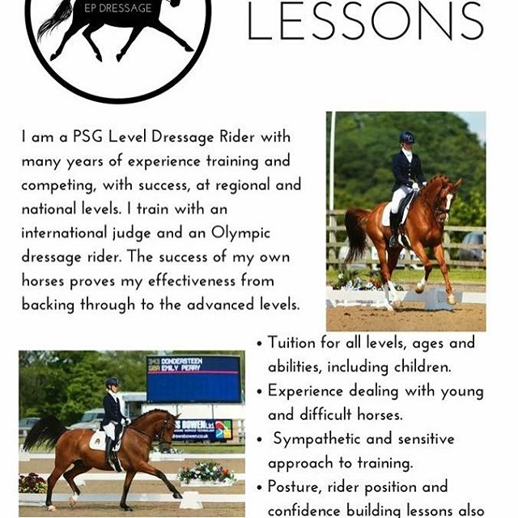About Emily

I am a level 2 UKCC qualified instructor who has trained horses from backing through to Grand Prix.

I have trained with Isobel Wessels and Richard Davison and compete my current 9 year old at Prix St George.

I am fully insured and CRB checked and have an up to date first aid certificate.

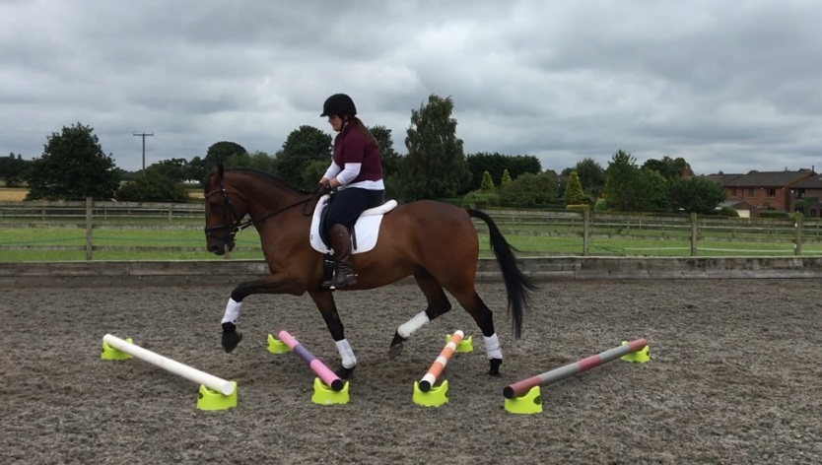

What is Cavaletti?

Cavaletti is a great exercise to develop suspension in the gate and increase the regulatory and rhythm. It builds strength and endurance and teaches your horse to go straight and keep a regular tempo. It's like a body pump session at the gym!

It's a really good way to add a bit of variety into training but still work your horse hard building up the correct muscles. It is a training method that is be beneficial for any discipline and any shape or size horse.

45min individual slots - £40

45min shared - £25 per rider

To book your lesson please contact 01995 642115. Payment will need to be made in advance.