Myerscough International Arena
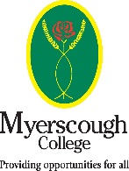
Clinics

With BD and BHS accredited coach and
List 2 BD Judge
Sarah Kingwells
All levels from Prelim to PSG
Private sessions available at £50 (40mins)

September 20th 5pm start
October 22nd 6pm start
November 20th 5pm start
December 17th 10am start
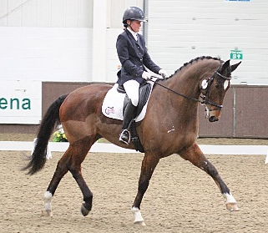

Contact Sarah for more information - 07706028652

