

**Myerscough College Clothing**

A range of items of clothing are available to purchase for all Myerscough College courses.

All will have the College logo embroidered along with the relevant curriculum area on the front left of the garment. The logo will be yellow with green background with the wording in yellow.

Hoodies, Soft Shell Jackets and Coats will also be embroidered on the back with the name of the relevant curriculum area.

Pre-orders can be emailed to [**clothing@myerscough.ac.uk**](mailto:clothing@myerscough.ac.uk) with payment taken over the phone on **01995 642115**. 24 hours should be left following submission of the order before ringing to process payment. Clothing will be available to buy/order on enrolment day in the foyer of the International Arena. In all cases, please allow up to 14 days for the items to be delivered. All clothing can be collected from the Equine Events Office in the International Arena.

For those students based at Witton Park or Croxteth, we advise placing your order via email or over the phone.

**Polo Shirt**

Available in black and navy to include left chest College logo and relevant curriculum area - **£15.00**

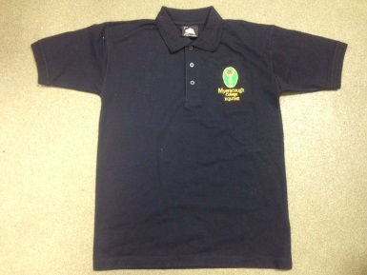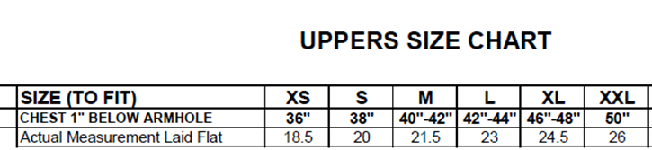

**Sweatshirt**

Available in black and navy to include left chest College logo and relevant curriculum area - **£20.00**

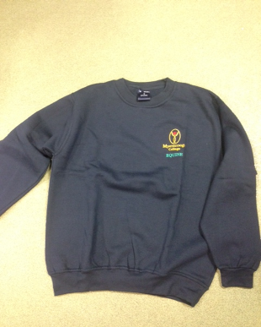

**Hoodie**

Available in black, navy or light grey to include left chest College logo and relevant curriculum area on front and back - **£27.00**

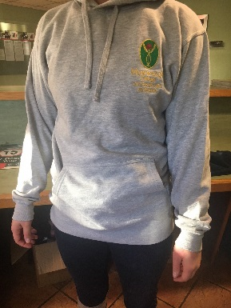

**Regatta Half Zip Fleece (over the head)**

Available in black and navy to include left chest College logo and relevant curriculum area - **£28.00**

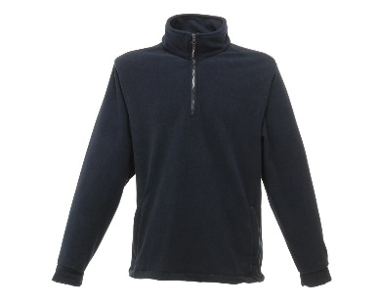**Sizes**

SMALL - 37/38”

MED - 39/40”

LARGE - 41/42”

X LARGE - 43/44”

2X LARGE - 46/48”

**Regatta Full Zip Fleece**

Available in black and navy to include left chest College logo and relevant curriculum area - **£29.00**

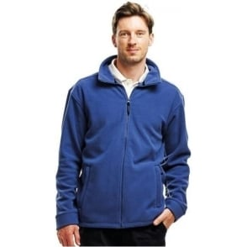**LADIES**

Size 10 to 18

**MENS**

SMALL - 41”

MED - 44”

LARGE - 47”

X LARGE - 50”

**Padded Gilet / Waistcoat**

Available in black or frost grey to include left chest College logo and relevant curriculum area - **£33.00**

**LADIES**

XS - 8

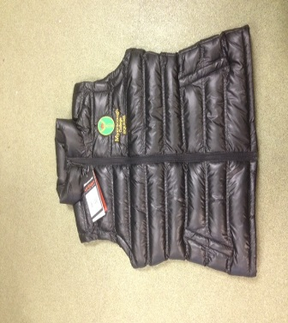S - 10

M - 12

L - 14

XL – 16

**MEN**

S - 38”

M - 41”

L - 44”

XL - 47”

2XL - 50”

**Soft Shell Jacket**

Available in black or navy to include left chest College logo and relevant curriculum area on front and back - **£40.00**

**LADIES**

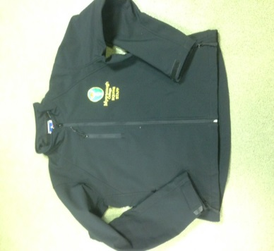XS - 8

S - 10

M - 12

L - 14

XL – 16

**MEN**

S - 36/38”

M - 38/40”

L - 41/42”

XL - 43/44”

**Waterproof Coat - Result Channel Jacket** (short blouson type elasticated bottom)

Available in black or navy, to include left chest College logo and relevant curriculum area on front and back - **£46.00**

**LADIES**

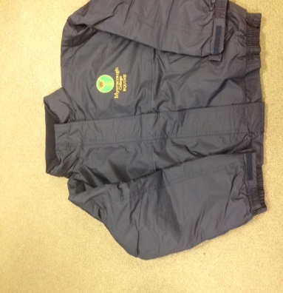XS - 8

S - 10

M - 12

L - 14

XL – 16

**MEN**

S - 38”

M - 41”

L - 42”

XL - 47”

2XL - 50”

**Waterproof Coat - Regatta Benson 3 in 1 Jacket** (longer length jacket with removable fleece)

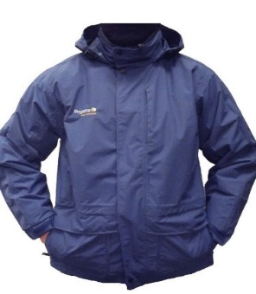Available in Black and Navy - **£62.00**

**LADIES**

Sizes 10 to 18

**MEN**

S - 37/38”

M - 39/40”

L - 41/42”

XL - 43/44”

**Waterproof Trousers**

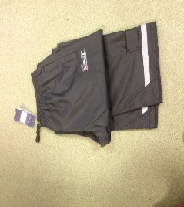Available in black with reflective strip - **£24.00**

Unisex Sizes - XS to XL

**SPECFIC COURSE GARMENTS**

**Animal Studies Work Coat**

Available in Black to include left chest College logo and relevant curriculum area - **£24.00**

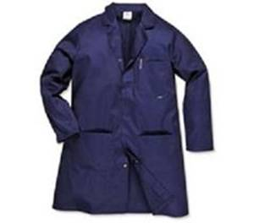**Sizes**

XS - 32/34”

S - 36/38”

M - 40/41”

L - 42/44”

XL - 46/48”

2XL - 50/52”

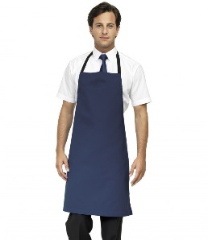**Floristry Apron**

Available in navy to include left chest College logo and relevant curriculum area - **£19.00**

**One Size**

**Motorsport Sebring Formula Racing Short Sleeve Shirt**

[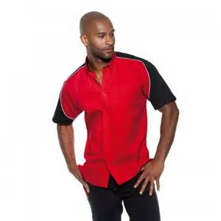](http://www.bing.com/images/search?q=SEBRING+FORMULA+RACING+SHORT+SLEEVE&view=detailv2&&id=ECD57575A040D12A951A361B150464E08AEF5D68&selectedIndex=2&ccid=HRO30iJ6&simid=608048605686072836&thid=OIP.M1d13b7d2227a42c76a0967147c250c79o0)Available in two tone red and black - **£30.00**

**Sizes**

S - 36/38”

M - 40”

L - 42”

XL - 44”

2XL - 46/48”

**Motorsport Monaco Formula Racing Polo Shirt**

Available in two tone red and black - **£25.00**

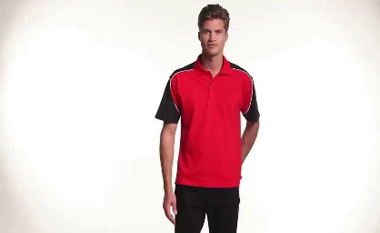

**Sizes**

S - 36/38”

M - 40”

L - 42”

XL - 44”

2XL - 46/48”

**Motorsport Result Soft Shell Jacket**

Available in two tone red and black - **£50.00**

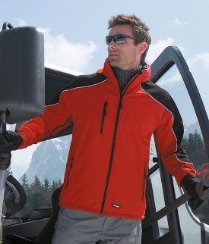

**Sizes**

XS - 34”

S - 38”

M - 41”

L - 44”

XL - 46”

2XL - 48”

**Motorsport Regatta Darby II Jacket**

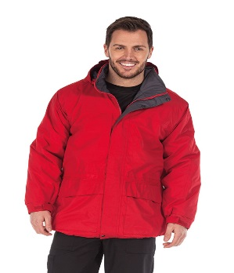Available in black/grey or red/grey - **£55.00**

**Sizes**

**MEN**

S - 37/38”

M - 39/40”

L - 41/42”

XL - 43/44”

**LADIES**

10 to 18

[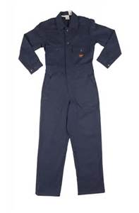](http://www.bing.com/images/search?q=fire+retardant+overalls&view=detailv2&&id=B74A19427955DEEB868C204155202EB7B0C34FF5&selectedIndex=2&ccid=nytiJusD&simid=608018738493525096&thid=OIP.M9f2b6226eb0344ca2a52ae14b9b8ab9cH0)**Motorsport Fire Retardant Overalls**

Embroidered front and back - **£50.00**

**Sizes**

S - 36/38” (L33”)

M - 40/40” (L33”)

L - 42/44” (L33”)

XL - 46/48” (L33”)

2XL - 50/52” (L33”)

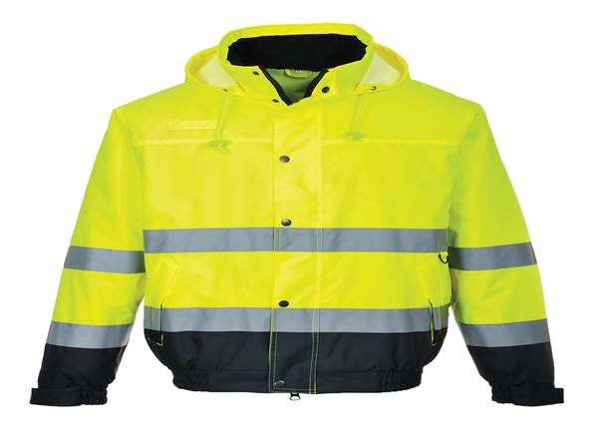**High Vis Bomber Jacket**

To include College logo and relevant curriculum area - **£34.00**

**Sizes**

Small - 36/38”

Med - 40/41”

L - 42/44”

XL - 46/48”