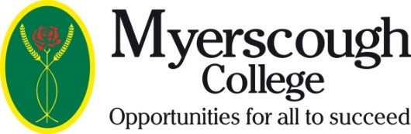

Myerscough College Clothing
Order Form

Name

Full Course Title

Campus

Item Name | Size | Colour | Quantity | Price per Item | Total Price
Total Price of Order

Completed Order Forms should be emailed to clothing@myerscough.ac.uk

Payment must be made by debit/credit card by calling: 01995 642115 (please allow 24 hours before calling to process payment to ensure we have received your order form

