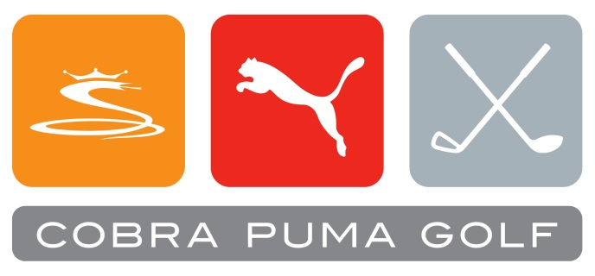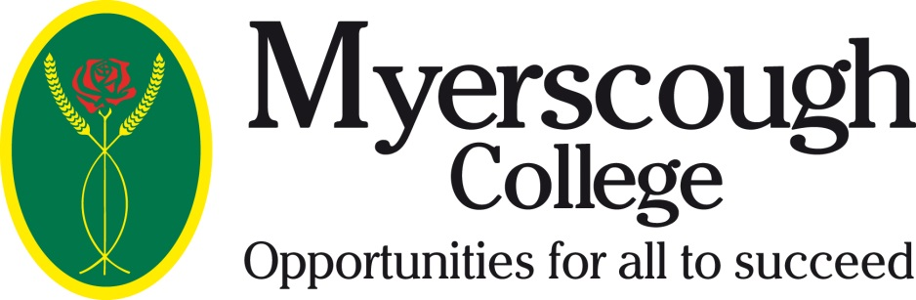

**Student Uniform Now Available**

The course you have applied for contains practical coaching days and an opportunity to play for and represent Myerscough College.

It is important that when representing the College locally or nationally you look professional and smart. With this in mind it is important that as Myerscough College students you have the right kit and clothing to participate in practical sessions.

As a college golf department we have made the decision that all Myerscough College golf students are required to wear the essential PUMA pack for coaching days and College events. This kit will be embroidered with the College logo(s):

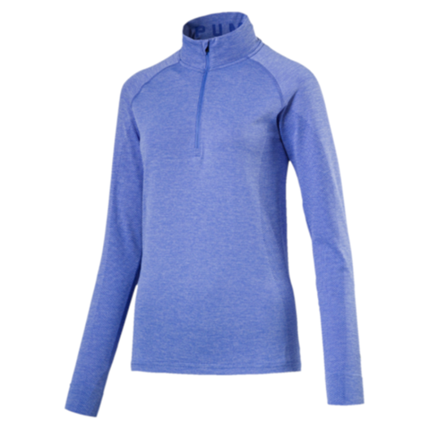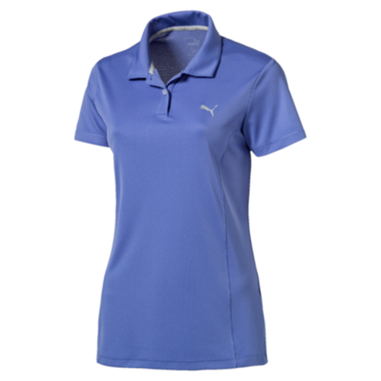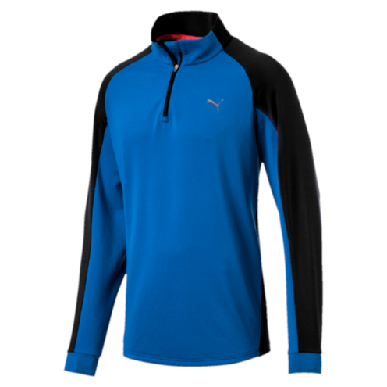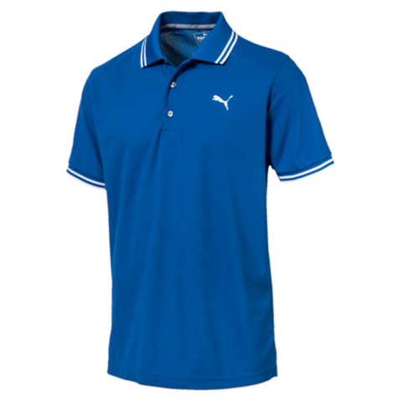

**Men’s Polo Men’s ¼ Popover Ladies Polo Ladies ¼ Popover**

**……………………………………………………………………………………………….....**

**NAME: ________________________________________________________**

**COURSE: ________________________________________________________**

**SIZE REQUIRED: Men: S – XXL; Ladies: 8 – 16; ____________________**

**Cost per pack: £75.00 cheques made payable to Myerscough College**

**ALL ORDERS REQUIRED BY 4.00PM ON FRIDAY, 15TH SEPTEMBER 2017**

**Return address** - FAO Golf Clothing/Craig Lea, Myerscough College

Bilsborrow, Preston, PR3 0RY