Guide: How to Apply for Accommodation
1) Log in to ProPortal
To apply for accommodation, you must first log in to ProPortal.
Login link:
https://mylearningplan-studentmyerscoughac.msappproxy.net/ProPortal/
Use the login details provided in your offer letter:
- Username: Your Myerscough email address <data:Myerscough Student Email Address>
- Password: Your date of birth in the format ddmmyyyy (no spaces or punctuation)
If you have changed your password and need it reset, contact the IT Team:
- Phone: 01995 642303
- Email: servicedesk@myerscough.ac.uk
2)Change the academic year to 26/27
Once logged in, change the academic year to 26/27 to view accommodation options for the next academic year.
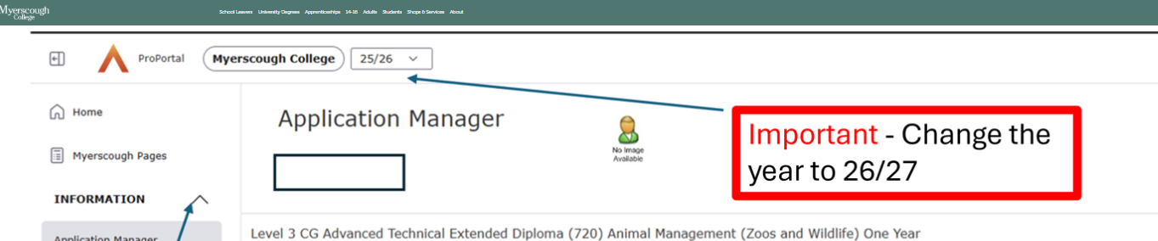
3) Ensure You Have Accepted Your Course Offer
You must accept your course offer before you can apply for accommodation.
Follow the steps shown here:
https://www.myerscough.ac.uk/media/mghjxpwd/how-to-accept-offer-on-pro-portal.png?width=1920&height=1032&quality=90&v=1dcaa45d437e310
If you experience any issues accepting your offer, contact the Admissions Team:
- Email: courseinfo@myerscough.ac.uk
3) Access the Accommodation Booking System
From the ProPortal menu, select “Myerscough Pages” to access the accommodation booking area.
4) Complete the Accommodation Request Form
Click on the Accommodation Request Form icon and complete the form to request accommodation
5) Make Your Advance Rent Payment
Select the basket icon to make the required £200 advance rent payment.
6) Complete Your Accommodation and Catering Licence
Your Accommodation and Catering Licence will be emailed to both you and your guarantor by the Accommodation Team. Please ensure this is completed promptly.
If you need support with your Accommodation and Catering licence, Contact the Accommodation Tea
- Email: reshelp@myerscough.ac.uk
7) Room Allocation
Your application will be reviewed by the Accommodation Team before a room is allocated.
- The first round of allocations will take place during the week beginning 22 June 2026, with confirmation emails sent out that same week.
- After this date, allocations will be processed in order of completed applications.
If you would like to enquire about your room allocation, contact the Accommodation Team:
- Email: reshelp@myerscough.ac.uk

