How long is the College day?
On Monday to Thursday, lessons start at 9:30am and finish at 4pm. On Friday’s lessons start at 10am and finish at 4pm.

What days will I be in College?
Your College programme is likely to be 3 days at Myerscough College. You will be informed of which days during the Transition Process.

What is an ILA?
Inclusive Learning Advisors (ILA) are similar to Learning Support Assistants or Teaching Assistants. An ILA will support the Tutor to deliver sessions and will also support you to complete tasks, activities and coursework.
Our ILA’s can also provide support for SaLT, Physiotherapy, Personal Care and the Administration of Medication.
ILA’s support students throughout the College day, including during lunch and break times.

What is a Transitions Advisor?
Before you start College and while you’re at College the Transitions Advisors are there for any questions or worries that you may have. Also, if you have an EHCP a Transitions Advisor will organise your Annual Review.

Where do I go for lunch?
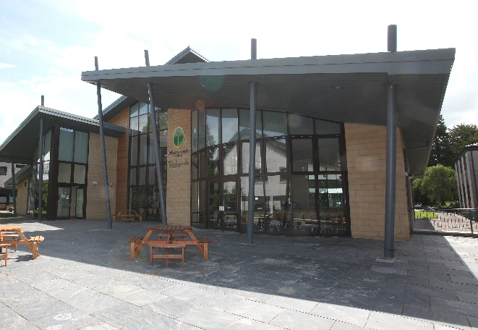
Richmond’s Restaurant, serves hot and cold food which you can eat in or take away.
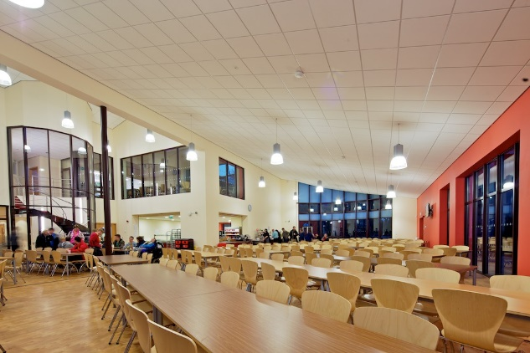

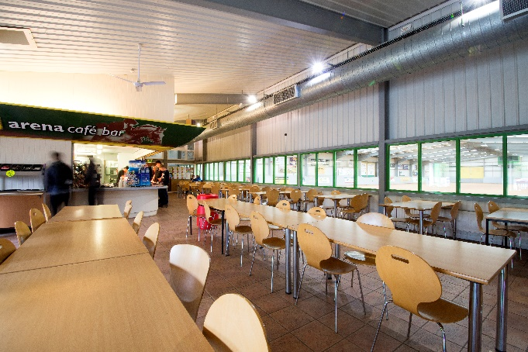
Arena Café (International Arena),
Serves hot and cold food which you
can eat in or take away.

Or you can purchase your lunch from our Sandwich Bar ‘Pickles’ or the Mini Market
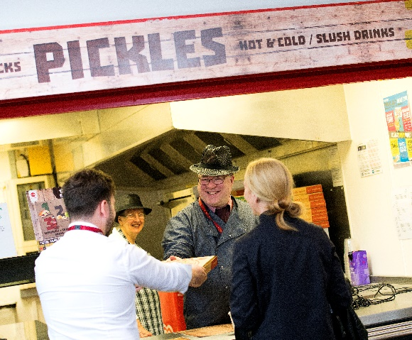

If you prefer a quieter place to eat your lunch then you can choose to stay in Foundation Learning.
You have the choice to purchase your own lunch or bring a packed lunch.

I had free school meals, will I get them at College?
Please contact the finance department for information about free meals, they will talk through finance information and you may be eligible to apply for a College Bursary too.
What is a Bursary?
A Bursary entitles eligible students to financial support, this support can be used for meal, resource, residential, travel and equipment costs. Please contact our finance team on 01995 642398 or email bursary@myerscough.ac.uk
If I feel worried, who can I talk to?
There are lots of people you can talk to if you feel worried:
Your Tutor
The ILA’s
Barry Sherriff (Head of Foundation Learning)
Carly-Ann Carson (Inclusive Learning Coordinator)
The Transitions Team
Student Support Officers

How will I get to College?
There are different ways to travel to Myerscough College, if you require Assisted Transport or information about Myerscough College’s dedicated bus services then please speak to the Transitions Team.

What will I need for College?
Your Tutor will inform you of what is needed for College, some tasks are outside, so it is recommended that you have appropriate clothing.

How long can I stay at College for?
Each course is 1 year long, during the year College will give you information about your options for further study and progression.

What else can I do at College?
At our Bilsborrow Campus we have lots of activities that you can do and get involved with, our Sports Activators organise lots of daily enrichment activities. We have a large sports hall, a 3G pitch, a gym (membership required) and a 9-hole Golf Course all available to students.
Also, there is the Stumble Inn, Myerscough’s own on-site Pub, which hosts parties, discos and quiz nights.
You can be become part of the Student Council and National Union of Students and have your say in how College is run.
Within Foundation Learning, we have a Pan-Ability Football Team that take part in tournaments throughout the North-West.
Through our partnership with Fleetwood Town Football Club, the NCS programme is available to students.
Further Activities for Foundation Learning Students.
End of Year Prom.
Health and Wellbeing Workshops.
PREVENT Workshop.
Quickfire Questions
What do I do if I get lost or can’t find where I’m going?
Every member of staff wears a Red Lanyard, you can ask any member of staff for help.
What if I feel nervous about starting College?
Please contact the Transitions Team and/or Barry Sherriff if you have any questions.
What if I start a course but don’t like it?
Let your Tutor and Barry know straightway so that they can help you and talk through your options.
Contact Information
Craig Dudding  Transitions Advisor  01995 642107 cdudding@myerscough.ac.uk | Available on Myerscough College’s Webchat:  Monday 9am – 11am  Wednesday 12pm – 2pm  Friday 9am – 11am
Karen Ball
Send Funding & EHCP Manager
01995 642107 kball@myerscough.ac.uk
Clare Moran  Transitions Advisor  01995 642107  cmoran@myerscough.ac.uk | Barry Sherriff  Head of Foundation Learning  01995 642222 ex 2526 bsherriff@myerscough.ac.uk
Julie Taylor  Recruitment & Admissions Coordinator  01995 642222 ex 2343  jtaylor2@myerscough.ac.uk | Carly-Ann Carson  Inclusive Learning Coordinator  01995 642107 or ex 2274 ccarson@myerscough.ac.uk
Rebekah Giles  Support & Wellbeing Coordinator  01995 642348  rgiles@myerscough.ac.uk | Finance & Bursary  01995 642398  bursary@myerscough.ac.uk

